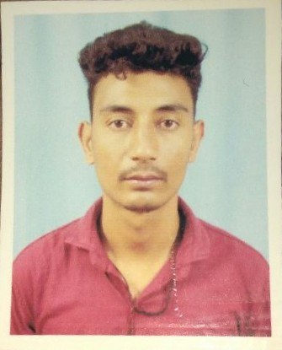
CURRICULUM VITAE

Ankit rawat
H. NO. 29 Circult house maholla W. NO. 1 P. O- PAURI. Teh- pauri. Dist- pauri
Mobile: +91-7060359659
Email ID:ankitrwt152@gmail. Com

CAREER OBJECTIVE:-
To obtain a high level of excellence and grow in the organization and to utilize myself as a resource for all kind of challenging jobs by upgrading my knowledge and skill from time to time.
ACADAMIC QUALIFICATION:-

- 10th Pass From CBSE BOARD IN ( S. G. R. R PAURI GHARWAL U. K)
- 12th Pass From ( S. G. R. R PAURI GHARWAL U. K)

ADDASITIONAL QUALIFICATION:-

- Basic Knowledge Of Computer.

Work Experience

- FRESHER and pursuing OPTOMETRY IN KMMOEI IN PAURI GHARWAL / 2 years experience in IENERGIZER NAPTOL TELECALLER PROCESS in Noida sector 60 A 37 pin 201301

PERSONAL DETAILS:-

Date of Birth : 2412/1994
Father `s Name : Mr. Anil singh rawat
Nationality : India
Languages Known : Hindi, English, ghadwali
Marital Status : married
Religion : Hindu
Date : …………………
Place : ………………… (ankit rawat)

